Water Monitoring & Purification Device sensors and their detection method.

pH sensors:
- The pH sensors can be detect by ESP32-S3 by connecting the sensor’s analog output to an analog input pin of ESP32-S3 GPIO36(VP).
- The ESP32-S3 reads the analog voltage from the pH sensor, and the associated code converts this reading into pH value.
- Hardware connections:
- Power supply connects the pH sensor module to an external power source to 5V.
- Analog input connects the sensor’s signal or output pin to an analog input pin on the ESP32-S3, such as GPIO36(VP) often used as an analog pin.
- Ground connects the sensor's ground pin to a ground pin on the ESP32-S3.
- Software connections:
- Upload code to the ESP32-S3 that reads the analog value from the input pin.
- Conversion:
Use the code to convert the raw analog-to-digital converter (ADC) value into a pH value. The output from the sensor is typically in the range of $0.5V$to $3V$.
- Calibration:
Calibrate the system by using standard buffer solutions (like pH 4.0, 7.0, and 10.0) and adjusting the code to match the known values.
- Specifications:
- Module power 5V.
- Module Size is 43x32mm(1.69x1.26)
- Measuring Range:0-14pH
- Measuring temperature:0-60 ℃
- Accuracy: ± 0.1pH (25 ℃)
- Response Time : ≤ 1min
- pH sensor with Bayonet Neill–Concelman (BNC) connector
- pH sensor interface(3 foot patch)
- Gain Adjustment Potentiometer
- Power indicator LED.
- Functions:
- The pH stands for power of hydrogen, which is a measurement of the hydrogen ion concentration (H⁺) in the body.
- The total pH scale ranges from 1 to14.
- 7 considered to be neutral.
- A pH less than 7 is said to be acidic solutions with a pH greater than 7 are basic or alkaline.
- Heating voltage:5±0.2V(AC-DC)
- Detecting temperature range:0-80℃(industrial).
- Component power:≤0.5W
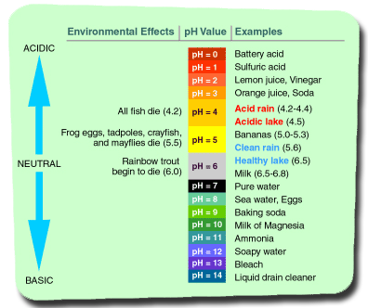
Figure 1:pH sensor range
- Applications:
- Water quality testing
- Aquaculture(aquatic organisms)
- Water and wastewater treatment (Water treatment and environmental monitoring)
- Environmental monitoring
- Swimming pools
- Quality and safety(Food and Beverage production)
- Fermentation
- Soil and hydroponics(Agriculture)
- Chemical production(Industrial and chemical processes)
- Power plants
- Drug and vaccine stability(Pharmaceuticals and medical applications)
- Medical testing
- Scientific experiments (Research and development)
- Product development
PalmSens EmStat Pico
- The EmStat Pico Development kit is equipped with a proven, tested and calibrated potentiostat module which enables rapid prototyping, no programming skills are needed.
- The EmStat Pico potentiostat development kit can detect heavy metals like lead and mercury, as well as other metal ions, in a water purification device when paired with the correct electrochemical sensor.
- The kit itself is a potentiostat module, a device that performs the electrical measurements, not the sensor itself.
Lead and Mercury detection
- Lead detection method is screen-printed electrodes(SPEs) can be modified to create biosensors for detecting heavy metals in real-water samples, offering a sample and affordable solution.
- Mercury detection method can be used to control the voltametric techniques (such as ASV) needed for detecting these metals.
Magnesium and Manganese detection
- Magnesium detection method has explored that the use of ISE(ion-selective electrode) to determine magnesium ion concentration.
- Manganese detection method has demonstrated the use of electrochemical sensors based on manganese and cobalt oxide nanostructures for the detection of various substances in water sample including manganese.
Specifications:
- EmStat Pico development Board with EmStat Pico Module.
- Standard sensor cable with 2mm banana pins and croc clips (electric connectors)
- Micro USB cable
- Dummy cell for evaluation purposes
- 8 GB SD Card
- Screen Printed Electrodes(SPE) adapter/connector
- Quick Start document.
- Card showing an overview of the development lab.
- Activation code card for registering on my.palmsens.com
Techniques:
- Voltametric techniques
- Linear Sweep Voltammetry(LSV)
- Cyclic Voltammetry(CV)
- Pulsed techniques
- Differential Pulse Voltammetry(DPV)
- Square Wave Voltammetry(SWV)
- Normal Pulse Voltammetry(NPV)
- Amperometric techniques
- Chronoamperometric (CA)
- Chrono coulometry(CC)
- Multi-Step Amperometry(MA)
- Pulsed Amperometric Detection(PAD)
- Potentiometric techniques
Open Circuit Potentiometry (OCV)
- Impedimetric techniques
- Potentiostatic Electrochemical Impedance Spectroscopy(PEIS)
- DC-potential sweep
- Impedance time scan
- Other techniques
- Mixed Mode(MM)
- Custom techniques (MethodSCRIPT)
- Bi Potentiostat techniques
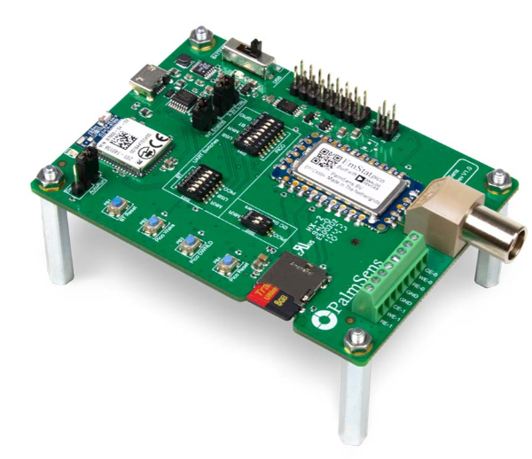
Figure 2:EmStat Pico module development kit
Detection Methods Mercury
ItalSens IS-HM
Mercury-film Graphite SPE
Supplier: ItalSens/PalmSens
Mercury-film Graphite SPE(Required Component):
- Yes, the ItalSens SPE for Heavy Metals detection can fulfill the requirements for detecting lead in purification devices because it is specifically designed for heavy metal quantification and uses stripping voltammetry to simultaneously measure multiple metals like lead, copper, and cadmium.
- The system requires a portable electrochemical instrument and is suitable for on-site, rapid detection of lead in various water samples.
Working of ItalSens IS-HM
- Electrochemical analysis is the ItalSens sensor that uses a modified-carbon working electrode in conjunction with a silver pseudo-reference electrode and a carbon counter electrode to measure electrochemical signals.
- Stripping voltammetry it is designed for stripping voltammetry, a technique that first deposits the metal ions onto the electrode and then strips them off by applying a potential to generate a signal. This allows for the quantification of multiple heavy metals in a single experiment.
- Simultaneous detection is a method that can simultaneously quantify multiple heavy metals, such as lead, copper, and cadmium, from a single sample.
Suitability for purification devices
- Portability:
The sensor is part of a system that enables portable, on-site analysis, which is ideal for testing water purification devices in the field.
- Rapid detection:
The technique offers rapid detection, providing results in minutes, which is faster than traditional laboratory methods like ICP-MS or AAS.
- Sensitivity:
The sensors are capable of detecting heavy metals at trace levels, making them sensitive enough for the rigorous testing of purified water.
- On-site verification:
It allows for real-time testing and verification of a device's performance to ensure it is effectively removing lead and other heavy metals from the water supply.
Specifications:
- Working Electrode (WE) material is carbon
- Brand name ItalSens
- Counter Electrode (CE) material Carbon
- Combined RE and CE No
- WE geometric area is 7.07 mm²
- Support material is Polyester
- Possible analytes are heavy metals
- Sensor type is Screen-printed
- Amount of WEs is 1
- Electrode system is CE + RE + WE
- Ø of the disc WE / mm is 3
- RE material is Silver
- Support dimensions / mm is 8 by 10
- Possible applications are Stripping Square Wave Voltammetry for Heavy Metal Trace Detection
- Thickness is 0.2 mm
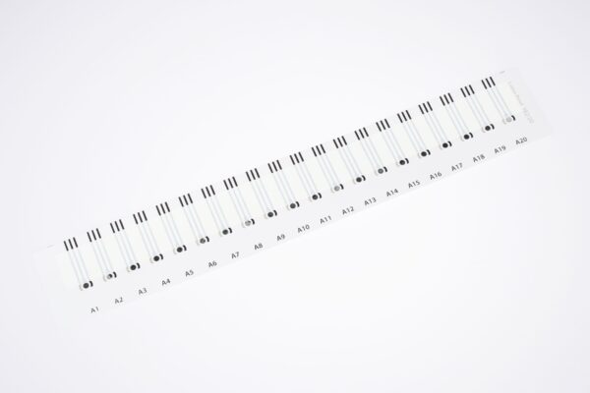
Figure 3:Mercury sensor ItalSens SPE for Heavy Metals detection

Metrohm DropSens C013 (Backup component)
Bismuth-film SPE
Supplier: Metrohm
The Metrohm DropSens C013 screen-printed electrode (SPE) cannot detect mercury on its own. As a carbon-based electrode, its surface does not have a strong affinity for mercury. To make the C013 suitable for mercury detection, it must be chemically modified.
Detecting mercury with a modified C013 electrode:
The C013 is an electrochemical platform for developers but requires specific modifications and an appropriate potentiostat to function as a mercury sensor.
- Modification of the electrode: The most effective method for mercury detection using screen-printed electrodes is to modify the working electrode. A common approach is to electrodeposit gold nanoparticles (AuNPs) or create a thin film of gold on the carbon surface.
- Mercury has a very high affinity for gold, forming an amalgam that can then be detected using an electroanalytical technique like Anodic Stripping Voltammetry (ASV).
- Use with a potentiostat: A potentiostat, like the EmStat Pico you mentioned previously, is required to perform the ASV measurement. This process involves two main steps:
- Deposition:
A specific voltage is applied to the electrode, causing the mercury ions in the water sample to deposit and form an amalgam with the gold on the electrode's surface.
- Stripping:
The voltage is then reversed, and the mercury is "stripped" from the electrode. The current generated during this stripping process is measured and is directly proportional to the concentration of mercury in the sample.
- Sensor pairing: To get the best results, you would need to use a potentiostat configured for ASV and connect it to a modified C013. A specialized gold SPE, such as one from the DropSens IS-Au series, is a more suitable choice for mercury detection than a carbon one, as gold naturally forms an amalgam with mercury, eliminating the need for a modification step

Features:
- Single to use sensors that eliminate the electrode maintenance.
- Specially designed to work with microvolumes, this inexpensive miniaturized solution presents high reproducibility making them ideal for working in decentralized assays or to develop (bio)sensors in environmental, clinical or agri-food areas.
- The different modifications applied to the working electrode provide an enhanced active area and improve the electron-transfer properties.
Specifications:
- Working electrodes (WE): 2, made of bismuth oxide/carbon
- Auxiliary electrode: Carbon
- Reference electrode: Silver
- Contacts: Silver
- Substrate: Ceramic
- Substrate dimensions: 3.38 cm (length) x 1.02 cm (width)x 0.05 cm (thickness)
Possible applications:
- Environmentally friendly determination of heavy metals at ppb levels, avoiding mercury based electrodes.
- Also ,this electrochemical platform is useful for developing other (bio)sensing applications in multiple sectors and fields.
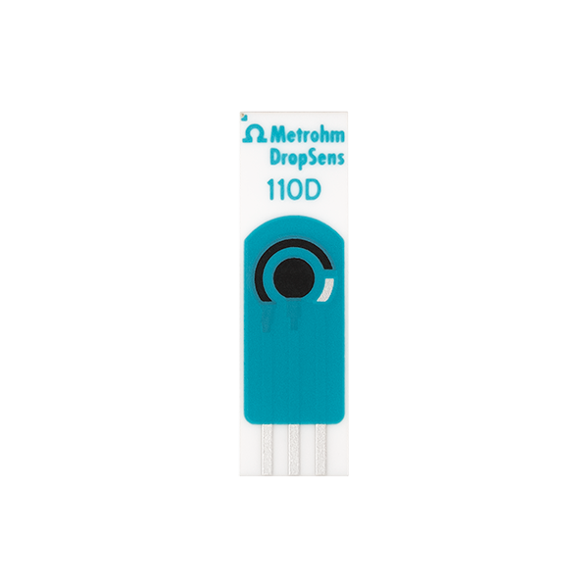
Figure 4: Bismuth oxide screen-printed carbon electrode

BVT AC1.W2.R1
Platinum/Ag-AgCl on Ceramic
Supplier: BVT Technologies
The BVT AC1.W2.R1 screen-printed electrode cannot detect mercury on its own. The "W2" in the product name indicates that it uses a platinum (Pt) working electrode. While platinum is an excellent electrocatalyst for some reactions, it is not suitable for detecting mercury through standard stripping voltammetry. To use an SPE for mercury detection, the working electrode must be made of a material that readily forms an amalgam (an alloy) with mercury. Gold (Au) is the preferred material for this purpose. When mercury ions (Hg²⁺) are deposited onto a gold electrode, they form an amalgam, which can then be "stripped" off by applying a reverse potential to create a current signal proportional to the concentration of mercury.
How to detect mercury using the BVT AC1 platform:
- If you need to use a BVT AC1 series sensor for mercury detection, you will need to:
- Select a different model: Choose a BVT sensor with a gold working electrode, such as the AC1.W1.R1, instead of the AC1.W2.R1.
- Use a potentiostat: Pair the gold SPE with a potentiostat, like the EmStat Pico, to perform an electrochemical technique such as Anodic Stripping Voltammetry (ASV).
- Perform the measurement: Apply a deposition potential to form the gold-mercury amalgam, then reverse the potential to "strip" the mercury and measure the resulting current peak
Platinum's role in electrochemistry:
- In electrochemistry, platinum is often used as a counter electrode or in rotating platinum electrodes where its wide potential range is beneficial.
- While a specialized research method exists to electrochemically form a platinum-mercury alloy for mercury retrieval, it is a complex process and not a standard method for simple, quantitative detection using an off-the-shelf SPE.
Specifications:
- AC1: Indicates the sensor is part of the AC1 series of electrochemical sensors from BVT Technologies.
- W2: Designates the working electrode (WE) material as pure Platinum, with a guaranteed purity of up to 99.95%.
- R1: Designates the reference electrode (RE) material as Ag/AgCl (Silver/Silver Chloride).
- Ceramic: The base substrate is corundum ceramic, which offers excellent resistance to temperature and organic solvents.
- Dielectric protection layer: A ceramic dielectric layer is fired at temperatures over 850°C to protect conductive lines, providing high chemical and thermal resistance.
- Electrode size: The working electrode diameter is 2 mm.
- Dimensions: 25.4 x 7.26 x 0.63 mm.
- Contacting field: Silver is used for the contacting fields.
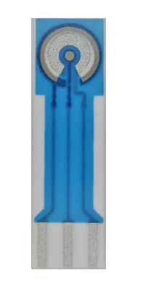
Figure 5: BVT SPE with single Working Electrode
Detection Methods
Lead
ItalSens IS-HM
Mercury-film Graphite SPE
Supplier: ItalSens/PalmSens
Yes, the ItalSens IS-HM Mercury-film Graphite SPE is specifically designed and advertised for detecting heavy metals, including lead, using stripping voltammetry. When paired with a potentiostat like the EmStat Pico, it can effectively monitor lead detection in water purification devices.
How the ItalSens IS-HM detects lead:
- Mercury-film modification: The sensor's graphite working electrode is pre-modified with a mercury salt-containing polymer. Before measurement, the salt is activated to form a very thin, environmentally minimized mercury film.
- Anodic Stripping Voltammetry (ASV): The ASV technique is used to quantify the lead present in the water sample.
- Deposition: A negative potential is applied, causing lead ions (Pb²⁺) to be reduced and deposited onto the mercury film, forming an amalgam.
- Stripping: The potential is then swept in a positive direction. The lead is "stripped" from the electrode, producing a measurable current peak. The height of this peak is proportional to the concentration of lead in the water.
- High sensitivity: This technique provides very high sensitivity, allowing for the detection of lead at the low parts-per-billion (ppb) level, which is well within the required range for monitoring water purity.
- Low-cost and practical: The IS-HM sensor is designed to be cost-effective and easy to use, making it suitable for practical applications like monitoring a purification device.
Pairing with the EmStat Pico
- The ItalSens IS-HM is designed to work seamlessly with potentiostat provided by PalmSens, the same company that supplies the EmStat Pico. The EmStat Pico provides the precise potential control needed to run the ASV measurement on the IS-HM sensor.
Important considerations:
While the IS-HM is effective for lead detection, remember the following:
- Mercury toxicity: The IS-HM uses mercury, a toxic substance, though the amount used per analysis is very small. Due to environmental and health concerns, some applications prefer non-mercury alternatives, such as bismuth-film electrodes.
- Calibration: The system will need to be calibrated with known lead standards to ensure accurate and reliable quantification.
- Interference: The measurement can be affected by the presence of other substances, such as surfactants and oils. For purification device monitoring, the water should be relatively clean, but proper sample preparation may still be necessary.
Specifications:
- Working Electrode (WE) material is carbon
- Brand name ItalSens
- Counter Electrode (CE) material Carbon
- Combined RE and CE No
- WE geometric area is 7.07 mm²
- Support material is Polyester
- Possible analytes are heavy metals
- Sensor type is Screen-printed
- Amount of WEs is 1
- Electrode system is CE + RE + WE
- Ø of the disc WE / mm is 3
- RE material is Silver
- Support dimensions / mm is 8 by 10
- Possible applications are Stripping Square Wave Voltammetry for Heavy Metal Trace Detection
- Thickness is 0.2 mm

Figure 6:Lead sensor ItalSens SPE for Heavy Metals detection
Metrohm DropSens C013 (Bismuth)
Bismuth-modified SPE
Supplier: Metrohm
Yes, a Metrohm DropSens C013 screen-printed electrode (SPE), when modified with a bismuth (Bi) film, can reliably detect lead and fulfill your requirements for monitoring a water purification device.
This approach is an environmentally friendly alternative to traditional, and highly toxic, mercury-based electrodes. When paired with a suitable potentiostat like the EmStat Pico, a bismuth-modified C013 SPE provides a sensitive and accurate system for lead detection.
How a bismuth-modified C013 detects lead
- Modification: The C013 SPE is a carbon electrode. To create a bismuth-modified electrode, bismuth (III) ions are added to the sample solution during the analysis, a process known as "in-situ plating".
- A reduction potential is applied, causing a thin film of metallic bismuth to deposit on the carbon surface.
- Anodic Stripping Voltammetry (ASV): Lead detection is performed using the ASV technique, which consists of two main steps.
- Preconcentration: The potentiostat applies a negative potential, causing lead ions (Pb²⁺) to be reduced and deposited into the bismuth film. The bismuth forms an alloy with the lead, effectively concentrating the lead on the electrode surface.
- Stripping: The potential is then scanned in a positive direction. The lead is "stripped" (re-oxidized) from the electrode, generating a peak current. The height of this peak is directly proportional to the lead concentration in the sample.
- High Sensitivity:
The use of ASV with a bismuth-modified SPE allows for the detection of lead at very low, trace levels (low parts-per-billion, or µg/L). This sensitivity is more than sufficient for monitoring compliance with drinking water regulations.
- Green Chemistry:
Bismuth is significantly less toxic than mercury, making this method a safer and more environmentally responsible choice.
Specifications:
- Working electrodes (WE): 2, made of bismuth oxide/carbon
- Auxiliary electrode: Carbon
- Reference electrode: Silver
- Contacts: Silver
- Substrate: Ceramic
- Substrate dimensions: 3.38 cm (length) x 1.02 cm (width)x 0.05 cm (thickness)
Possible applications:
- Environmentally friendly determination of heavy metals at ppb levels, avoiding mercury based electrodes.
- Also ,this electrochemical platform is useful for developing other (bio)sensing applications in multiple sectors and fields.

Figure 7: Bismuth oxide screen-printed carbon electrode
BVT AC1.W4.R1 (Activated)
Carbon/Graphite SPE on Ceramic
Supplier: BVT Technologies
An activated BVT AC1.W4.R1 carbon/graphite screen-printed electrode (SPE) can be modified to detect lead, but it is not a ready-made solution. The activation process is key to making the electrode suitable for the sensitive detection of lead required for monitoring a purification device.
How the BVT AC1.W4.R1 can be used to detect lead:
The BVT AC1.W4.R1 uses a carbon/graphite working electrode. While carbon can be used for some electrochemical measurements, it often requires modification to become sensitive and selective enough for trace heavy metal detection.
- Electrode activation:
BVT Technologies offers an activation service for the W4 electrode or provides guidance on how to activate it yourself. Activation typically involves cleaning the electrode surface and introducing specific chemical functionalities that improve its electrochemical properties. This process is crucial for achieving precise and reproducible results.
- Chemical modification:
The activated carbon electrode can be further modified with a non-toxic metal film, most commonly bismuth. This can be done in-situ (during the measurement by adding bismuth ions to the sample) or ex-situ (by pre-depositing the film). The bismuth film is a critical component for sensitive heavy metal detection, as it effectively concentrates the lead from the sample through amalgamation.
- Electrochemical technique: The modified electrode is then used with a potentiostat (like the EmStat Pico) to perform Anodic Stripping Voltammetry (ASV). This technique involves:
- Preconcentration: Applying a negative potential to deposit lead ions (Pb²⁺) onto the bismuth film on the electrode.
- Stripping: Reversing the potential to oxidize the deposited lead, producing a measurable current peak. The height of this peak is proportional to the lead concentration.
Specifications:
- AC1: Indicates the sensor is part of the AC1 series of electrochemical sensors from BVT Technologies.
- W2: Designates the working electrode (WE) material as pure Platinum, with a guaranteed purity of up to 99.95%.
- R1: Designates the reference electrode (RE) material as Ag/AgCl (Silver/Silver Chloride).
- Ceramic: The base substrate is corundum ceramic, which offers excellent resistance to temperature and organic solvents.
- Dielectric protection layer: A ceramic dielectric layer is fired at temperatures over 850°C to protect conductive lines, providing high chemical and thermal resistance.
- Electrode size: The working electrode diameter is 2 mm.
- Dimensions: 25.4 x 7.26 x 0.63 mm.
- Contacting field: Silver is used for the contacting fields.

Figure 8:BVT SPE with single Working Electrode
OG Carbon New Silver
Carbon SPE with Ag/AgCl
Supplier: OG Carbon
Similar to other carbon-based electrodes, the OG Carbon New Silver Carbon SPE with Ag/AgCl can detect lead only when chemically modified. The sensor on its own lacks the necessary sensitivity and selectivity for trace heavy metal analysis required to monitor a water purification device. The Ag/AgCl component in this electrode refers to the reference electrode, which is standard for ensuring stable potential control during electrochemical measurements but does not contribute to the direct detection of lead. The detection capability resides solely with the carbon working electrode, which must be modified.
How to use the OG Carbon SPE for lead detection:
- Chemical Modification:
The working electrode surface must be modified with a material that can effectively preconcentrate and detect lead ions.
- The most common and environmentally friendly approach is to modify the electrode with a bismuth (Bi) film. A non-toxic bismuth salt is added to the sample and electrochemically deposited onto the carbon working electrode during the analysis (in-situ plating).
- The bismuth forms an alloy with the lead ions in the water sample, concentrating them on the electrode surface.
- Electrochemical Technique:
The modified electrode is then paired with a potentiostat (such as the EmStat Pico) to perform Anodic Stripping Voltammetry (ASV).
- Preconcentration:
A potential is applied to deposit lead ions (𝑃𝑏²⁺) onto the bismuth film.
- Stripping:
The potential is then swept in a positive direction. The lead is "stripped" from the electrode, generating a peak current that is proportional to its concentration.
- High Sensitivity:
When properly modified and used with ASV, the OG Carbon SPE can achieve the low limits of detection necessary for monitoring lead levels in purified water.
Specifications:
- WE material:Carbon
- Brand: OG Carbon
- CE material: Carbon
- Combined RE and CE: No
- WE geometric area: 12.57 mm²
- Support material: White PET
- Possible analytes: naphthol, dopamine, metals, para-aminophenol, metal complexes, other redox active species
- Sensor type: Screen-printed
- Thickness: 0.3 mm
- Surface modification: Blank
- Amount of WEs:1
- Electrode system: CE + RE + WE
- Ø of the disc WE / mm :4
- RE material: Silver and Silver Chloride Mixed
- Support dimensions / mm: 10 by 33
- Possible applications: Electrolysis, Modification with biomolecules, aryl layers (diazonium chemistry) or similar, Detection of redox active species.
- WE/CE material:Carbon, Carbon with Silver Underlayer
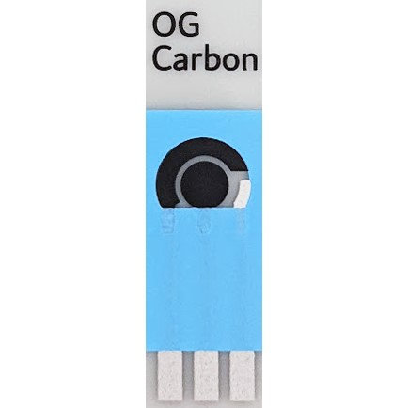
Figure 9: OG Carbon SPE
Detection Methods
Magnesium
NT Sensors Magnesium ISE (S024)
Ion-Selective Electrode
Supplier: NT Sensors
Yes, the NT Sensors Magnesium ISE (S024), an ion-selective electrode, is designed to measure magnesium concentration and can fulfill your requirements for detecting magnesium in a water purification device.
How the S024 ISE works:
- Selective membrane:
The electrode has a PVC (polymer) membrane with a sensor that is highly selective for magnesium ions (Mg²⁺).
- Potential change:
The selective membrane allows only magnesium ions to pass through, creating an electrical potential difference (measured in mV) that is proportional to the concentration of magnesium in the solution.
- Nernstian response:
The electrode potential response follows the Nernst equation, which is used to calibrate the electrode and convert the measured potential into a magnesium concentration.
- Two electrodes required:
The S024 is a half-cell electrode. You will need to use it with a separate, standard reference electrode to complete the circuit and obtain a stable potential reading.
Requirements for monitoring water purification:
- Monitoring total hardness:
The S024 is particularly useful for monitoring water hardness, as magnesium is a key contributor to it. In water purification, this could be used to verify that a softening process is working correctly.
- Wide application range:
NT Sensors markets the electrode for use in drinking water, mineral water, and seawater, indicating its suitability for various aqueous samples.
- Compatibility:
The S024 can be connected to any standard ion or millivolt (mV) meter, but it can also be used with a potentiostat like the EmStat Pico, although potentiometry (measuring potential) is a different technique than the voltammetry typically used for heavy metals.
- Calibration standards:
As with all ion-selective electrodes, accurate results require proper calibration using standard solutions with known magnesium concentrations.
Considerations for use:
- Interference: While selective, the electrode can be affected by other ions, such as calcium (Ca²⁺) and potassium (K⁺).
- In applications where calcium levels are much higher than magnesium, this could affect the accuracy of the measurement, potentially requiring a compensating reagent to improve selectivity.
- pH and temperature:
The electrode has specified operational ranges for both pH (3 to 8.5) and temperature (5 to 50°C), so these environmental factors must be controlled or compensated for.
- Long-term storage:
The electrode's sensor tip is replaceable and can be stored dry, which helps with long-term maintenance and ease of use.
Specifications:
- Single Ion Probe
- Mini ISE for Magnesium (Mg2+)
- User’s manual
- UEF: S024
- Diameter: 12 mm
- Length: 150 mm
- Connector: BNC Cable: 1m
- Linear Range: 2.4 to 2400 mg/L – 1e-4 to 0.1 mol/L
- Single Ion Compatible: Standard Ion/mV/pH Meters
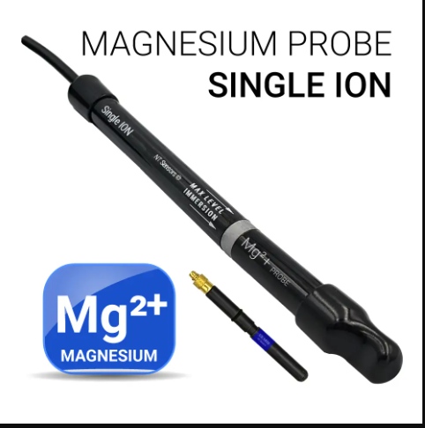
Figure 10: Magnesium Ion Selective Electrode
Detection Methods
Manganese
ItalSens IS-HM
Mercury-film Graphite SPE
Supplier: ItalSens/PalmSens
While the ItalSens IS-HM mercury-film graphite screen-printed electrodes (SPEs) from PalmSens are highly effective for detecting heavy metals like lead (Pb), cadmium (Cd), and copper (Cu) using stripping voltammetry, they are not typically used for manganese (Mn) detection. Manganese requires a different type of detection method or electrode modification.
Why the IS-HM is not suited for manganese:
- Methodology:
The IS-HM sensor works by using a thin mercury film to concentrate specific metals through a process called anodic stripping voltammetry (ASV).
- Incompatibility with manganese:
Manganese does not deposit well onto a mercury-film electrode in the same way as other heavy metals, making detection by this method difficult. This is a known limitation of using mercury-based ASV for manganese.
Alternative methods for manganese detection:
Since the IS-HM is not the right tool for this task, you would need to use a different approach. PalmSens and its partners offer alternative methods and sensors for manganese analysis:
- Stripping chronopotentiometry (SCP):
This technique, offered by PalmSens, is a robust alternative for manganese detection. It involves a different electrochemical process that can effectively measure manganese levels.
- Bismuth film electrodes:
Another alternative is to use a bismuth-film electrode instead of a mercury-film one. Bismuth is a more environmentally friendly material and can be used for the stripping analysis of certain metals, including manganese.
- Specific manganese sensors:
We should contact PalmSens or its suppliers directly to inquire about specific sensors or application notes tailored for manganese detection. They may offer different screen-printed electrodes designed for this particular heavy metal.
Specifications:
- Working Electrode (WE) material is carbon
- Brand name ItalSens
- Counter Electrode (CE) material Carbon
- Combined RE and CE No
- WE geometric area is 7.07 mm²
- Support material is Polyester
- Possible analytes are heavy metals
- Sensor type is Screen-printed
- Amount of WEs is 1
- Electrode system is CE + RE + WE
- Ø of the disc WE / mm is 3
- RE material is Silver
- Support dimensions / mm is 8 by 10
- Possible applications are Stripping Square Wave Voltammetry for Heavy Metal Trace Detection
- Thickness is 0.2 mm

Figure 11:Manganese sensor ItalSens SPE for Heavy Metals detection
Detection Methods
BVT AC1.W4.R1 (Activated)
Carbon/Graphite SPE on Ceramic
Supplier: BVT Technologies
BVT Technologies AC1.W4.R1 (Activated) Carbon/Graphite Screen-Printed Electrodes (SPEs) can be used for manganese (Mn) detection, but with some important considerations. Unlike the previous mercury-film electrodes, carbon/graphite SPEs offer a more versatile platform, and specialized methods exist to make them sensitive to manganese.
How carbon SPEs can be used for manganese detection:
While standard stripping voltammetry on carbon electrodes may not be effective for manganese, several modification and technique-based approaches allow for its detection:
- Adsorptive stripping voltammetry (AdSV):
This method involves adding a chelating agent, or "complexing ligand," to our sample solution. This ligand selectively binds with Mn(II) ions to form a complex that is easily adsorbed onto the surface of the carbon electrode. A stripping step then measures the electrochemical response of the accumulated complex, allowing for highly sensitive detection.
- Cathodic stripping voltammetry (CSV):
Manganese can also be detected using CSV, where the electrode is modified with an agent that concentrates the Mn(II) ions, and the signal is measured during a negative-going potential scan. One study showed a sensitive method for Mn detection using stencil-printed carbon ink electrodes with the addition of 1,4-benzoquinone.
- Electrode surface modification:
Researchers have found that modifying the surface of carbon electrodes with certain materials can significantly enhance their sensitivity to manganese. For example, some approaches use metal oxides like manganese dioxide or other composite materials
Activated electrode functionality:
The term "Activated" in the BVT AC1.W4.R1 model is key here. BVT Technologies offers unactivated versions for general use, but the activated version is typically prepared for specific applications. This "activation" process can involve:
- Surface cleaning:
Removing oxides and organic impurities to expose a fresh, consistent carbon surface.
- Electrochemical pretreatment:
Conditioning the electrode to make it more sensitive to a particular analyte.
For manganese detection, this activation or customization is likely required. We would need to work with BVT or follow a specific protocol to prepare the electrode surface for our application.
Specifications:
- Sensor type: AC1 (Amperometric sensor on corundum ceramic base)
- Working Electrode (WE): Carbon (graphite)
- Reference Electrode (RE): Silver/Silver Chloride (R1)
- Support Material: Ceramic (corundum)
- Activation: The sensor is pre-activated.
- Electrodes: Includes a working electrode, a reference electrode, and an auxiliary electrode.
- Optional features: Can be equipped with a hydrophobic ring to confine liquid to the working electrode, or with a heating and temperature sensing element.
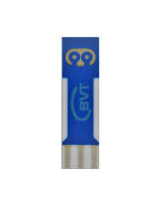
Figure 12: BVT SPE with single Working Electrode
Detection Methods
Manganese
MicruX Carbon S1PE
Thick-film Carbon Single Electrode
Supplier: MicruX
Yes, MicruX Carbon S1PE thick-film electrodes can be used for manganese detection, but similar to the BVT carbon electrodes, they are not inherently sensitive to manganese. You would need to use a specific electroanalytical method, such as adsorptive stripping voltammetry (AdSV) or cathodic stripping voltammetry (CSV) and possibly modify the electrode surface.
Principles for using carbon electrodes for manganese detection:
Standard stripping voltammetry is ineffective for manganese because manganese(II) ions do not typically plate onto a carbon surface. However, electrochemical methods can be adapted to enable detection.
- Electrode modification:
Researchers often modify carbon electrodes with other materials to improve their sensitivity and selectivity for manganese. One effective approach involves depositing a layer of manganese dioxide (MnO₂) on the carbon surface.
- Adsorptive stripping voltammetry (AdSV):
This method uses a chelating agent (a ligand) that binds to manganese ions(Mn²⁺) in the solution.
- This manganese-ligand complex then accumulates (adsorbs) on the carbon electrode surface during a preconcentration step.
- Oxine (8-hydroxyquinoline) has been shown to be an effective ligand for this purpose.
- Cathodic stripping voltammetry (CSV): Another technique for detecting manganese involves oxidizing Mn(II) to insoluble manganese dioxide (MnO₂) on the electrode surface during a preconcentration step. A subsequent negative potential scan (stripping) then reduces the MnO₂ back to Mn(II), producing a measurable current.
MicruX also offers mediated electrodes (e.g., S1PE-C20/MED and S1PE-C30/MED), which are specifically pre-treated for biosensor applications involving other substances but are likely not suitable for manganese detection without further modification.
Detection steps:
To successfully detect manganese using the MicruX Carbon S1PE electrodes, we should:
- Contact MicruX:
Consult MicruX directly or a distributor to inquire about specific application notes or protocols for manganese analysis with their carbon electrodes.
- Select a method:
Plan our experiment using either an AdSV or CSV technique, as bare carbon electrodes are not sufficient for this analysis.
- Optimize your conditions:
If using AdSV, we will need to select an appropriate chelating agent and supporting electrolyte buffer (e.g., acetate buffer at pH 5.0). You should also optimize parameters like pH, accumulation time, and scan rate to maximize sensitivity and minimize interference.
Specifications:
- Product: Thick-film Carbon Single Electrode (S1PE)
- Supplier: MicruX Technologies
- Working Electrode (WE) :Carbon (Performance or Low Cost ink)
- Auxiliary Electrode (AE): Carbon
- Reference Electrode (RE):Silver or Silver/Silver Chloride (Ag/AgCl)
- Substrate: PET (White)
- Substrate Thickness:250 µm (PET) or 380 µm (Ceramic option)
- External Dimensions: 27.5 x 10.1 mm
- Working Electrode Dimensions:3 mm Ø (7.1 mm²)
- Sample Volume:20–50 µL
- Packaging:50 units per pack
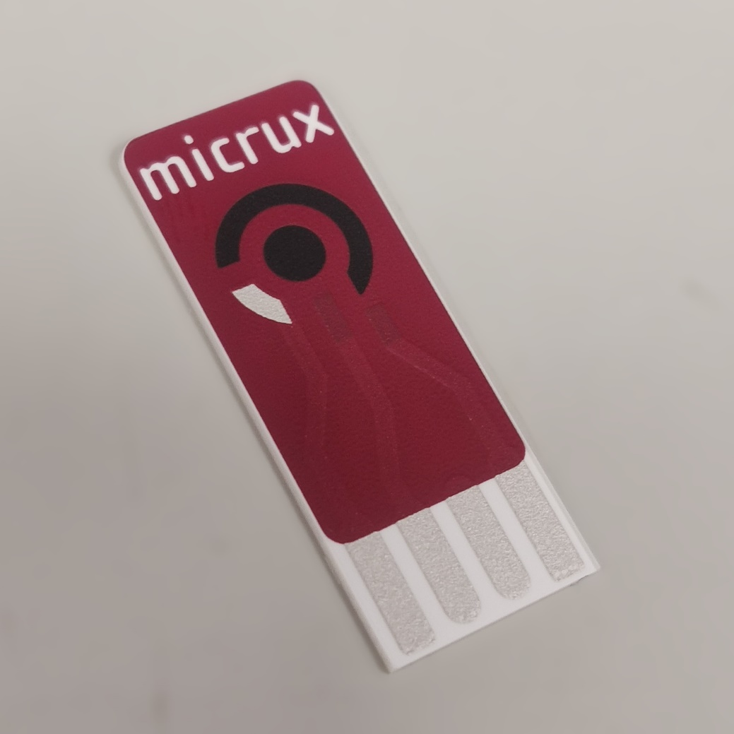
Figure 13: MicruX Carbon S1PE

Detection Methods
Manganese
OG Carbon New Silver
Carbon SPE with Ag/AgCl
Supplier: OG Carbon
Yes, OG Carbon "New Silver" Carbon SPEs can be used for detecting manganese, but only by adapting the electrochemical methodology. The integrated silver/silver chloride (Ag/AgCl) reference electrode simplifies the setup, but the core challenge of detecting manganese on a carbon working electrode remains.
How to use OG Carbon SPEs for manganese detection:
Since manganese(II) ions do not directly preconcentrate on a standard carbon electrode, a specialized stripping voltammetry method is required.
- Adsorptive cathodic stripping voltammetry (AdCSV):
This is the most common and effective method for manganese detection using carbon electrodes. It involves adding a chelating agent to the sample solution.
  - The chelating agent selectively binds with manganese ions to form a stable, electrically active complex.
  - This complex is then accumulated onto the carbon working electrode during a preconcentration step.
  - A stripping step, typically involving a negative potential scan, reduces the complex and produces a measurable current peak proportional to the manganese concentration.
- Electrode surface modification:
For certain applications, an even more sensitive method can be achieved by first modifying the carbon electrode surface. For example, depositing a layer of manganese dioxide (MnO₂) on the carbon can enhance the electrochemical signal for manganese.
Advantages of the integrated Ag/AgCl reference electrode:
The "New Silver" SPE offers a significant practical advantage with its integrated Ag/AgCl reference electrode.
- Simplified setup:
The reference electrode is printed directly on the same substrate as the carbon working and counter electrodes, eliminating the need for an external reference electrode and a separate salt bridge.
- Improved consistency:
Having a stable, integrated reference electrode leads to greater measurement reproducibility and consistency, which is especially important for stripping analysis.
Specifications:
- Working electrode: Carbon
- Auxiliary electrode: Carbon
- Reference electrode: Silver / Silver chloride (Ag/AgCl)
- Substrate: Ceramic
- Substrate size: 3.38 cm (length) x 1.02 cm (width)
- Number of working electrodes: 1

Figure 14: OG Carbon New Silver

